Exp 1: Analysis Development and Verification of 8 bit and 16 bit Arithmetic operation using Assembly Language program
Objective
- To Develop and Verify 8 Bit Addition and Subtraction
- To Develop and Verify 16 bit Addition and Subtraction
- To Develop and Verify 8 bit Multiplication and Division
- To Develop and Verify 16 bit Multiplication and Division
Components Required:
8085 Simulator (or )8085 intel microprocessor
Procedure
- Open the 8085 simulator.
- Enter the required assembly language program.
- Enter the input data into the specified memory locations.
- Execute the program step by step or run it.
- Check the accumulator and register contents after execution.
- Verify the result stored in the specified memory location.
- Repeat the same procedure for 8-bit and 16-bt addition, subtraction, multiplication and division.
- Record the results and compare them with the expected output.
- To Develop and Verify 8 Bit Addition and Subtraction
- To Develop and Verify 8 Bit Addition and Subtraction
- To Develop and Verify 8 bit Addition and Subtraction
8-bit Additon
Program
LDA 2050H
MOV B,A
LDA 2051H
ADD B
STA 2052H
HLT

Output: 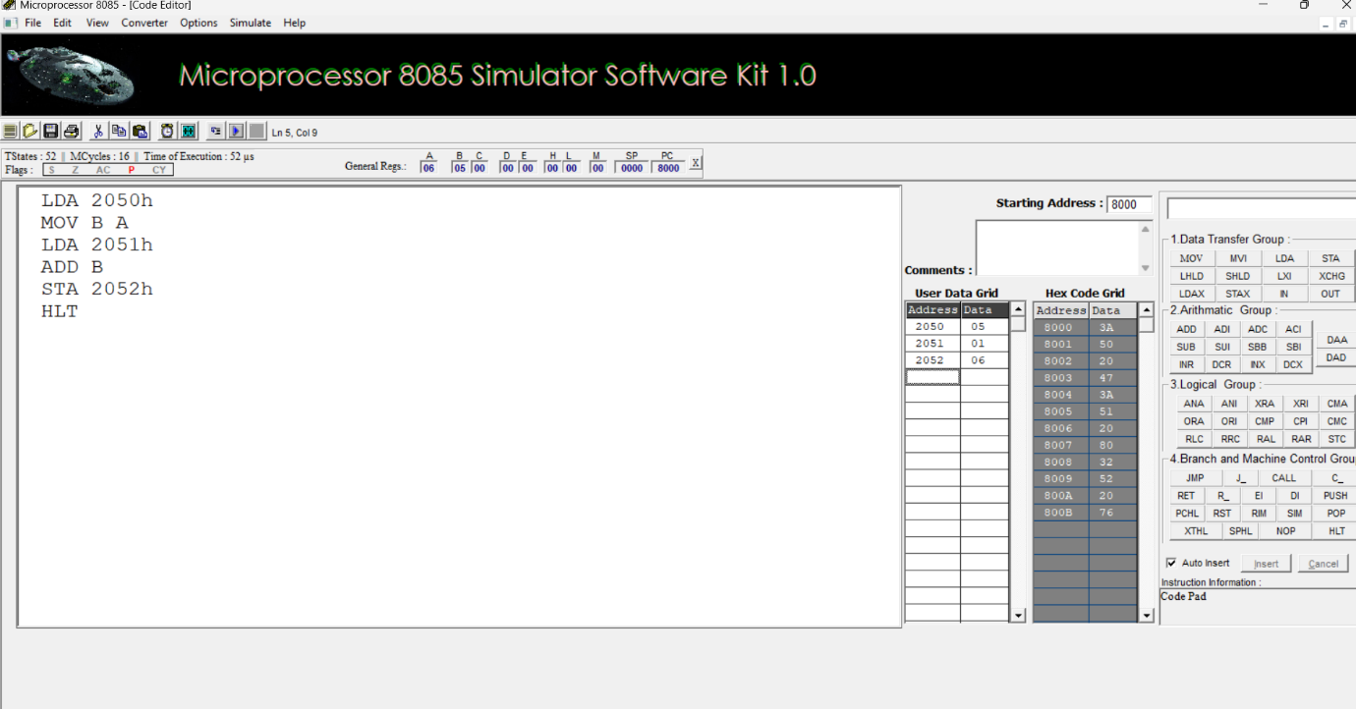

8-bit Subtraction
Program
LDA 2050H
MOV B,A
LDA 2051H
MOV C,A
MOV A,B
SUB C
STA 2052H
HLT
OUTPUT
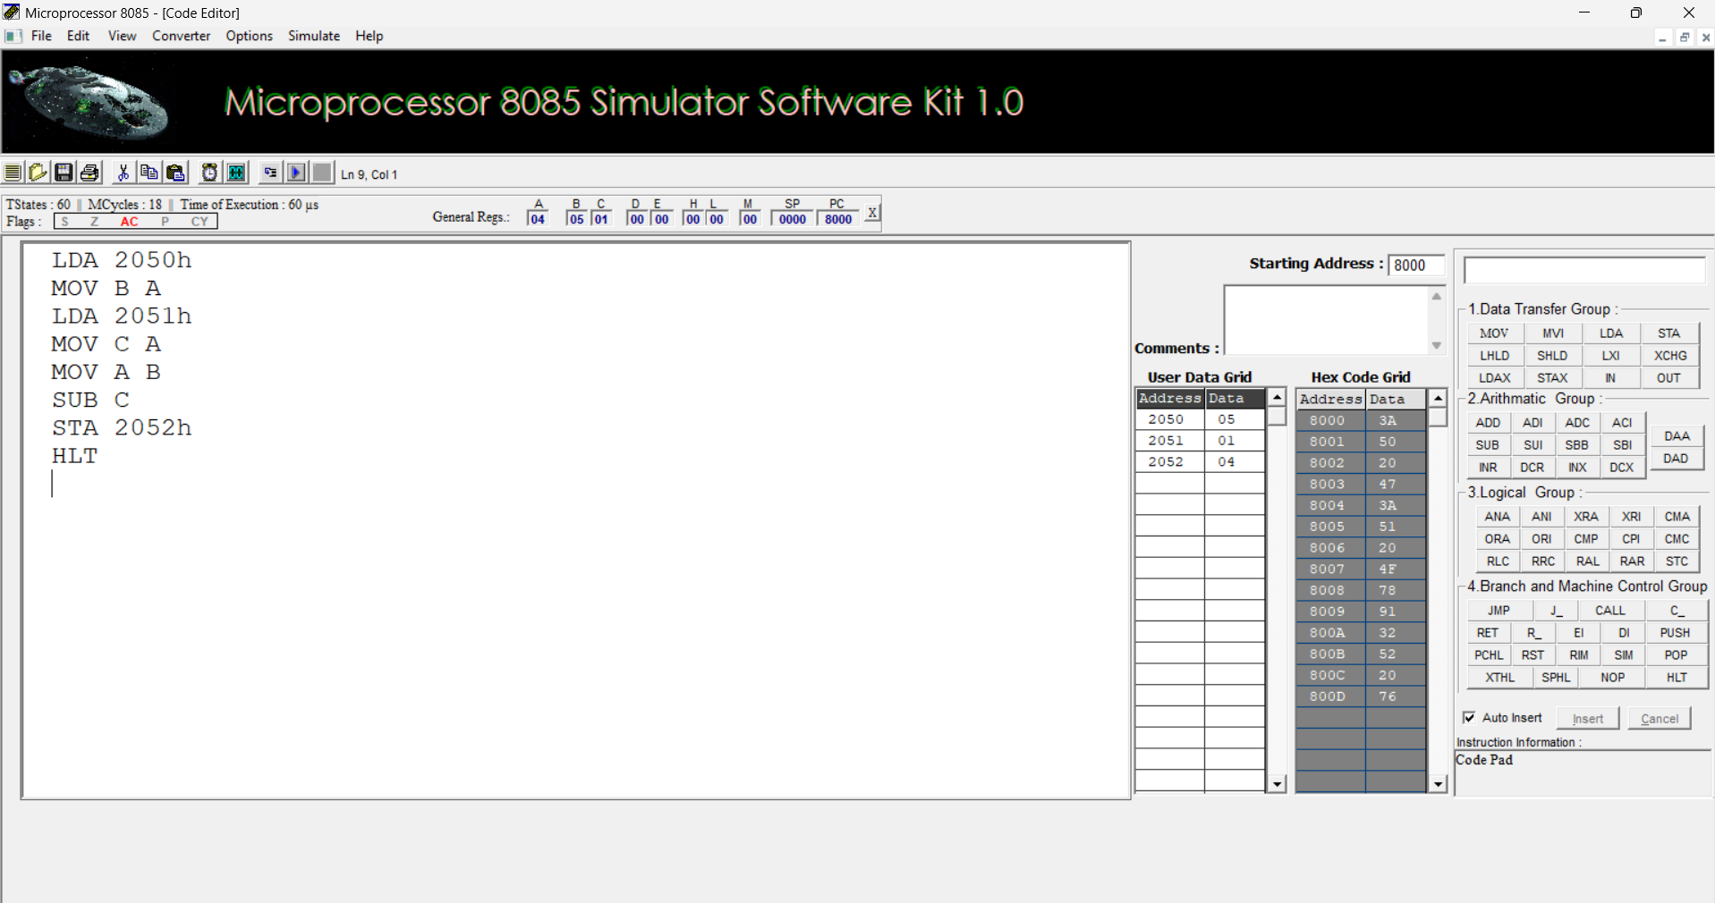

To Develop and Verify 16 bit Addition and Subtraction
16-bit Additon
Program
LHLD 2050H
XCHG
LHLD 2052H
DAD D
SHLD 2054H
HLT
OUTPUT :

Memory Address :
16-bit Subtraction
CODE
LHLD 2050H
XCHG
LHLD 2052H
XCHG
MOV A,L
SUB E
MOV L,A
MOV A,H
SBB D
MOV H,A
SHLD 2054H
HLT
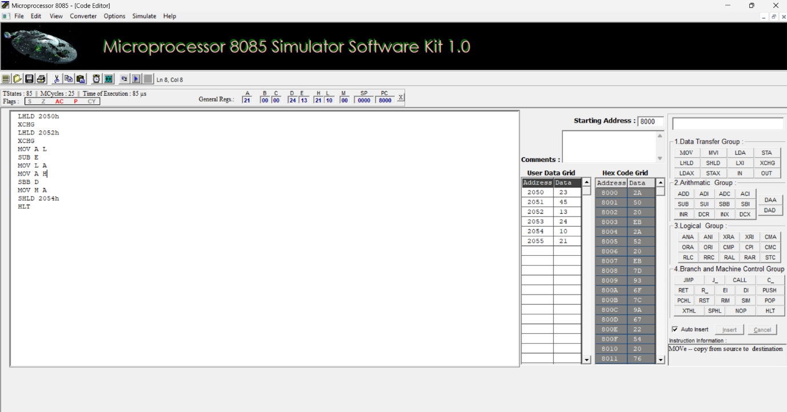
Output:

- To Develop And Verify 8 bit Multiplication And Division
8 bit Multiplication
Program :

LDA 2050H
MOV B,A
LDA 2051H
MOV C,A
MVI D,00H
MVI A,00H
LOOP: ADD B
DCR C
JNZ LOOP
STA 2052H
MOV A,D
STA 2053H
HLT
OUTPUT:
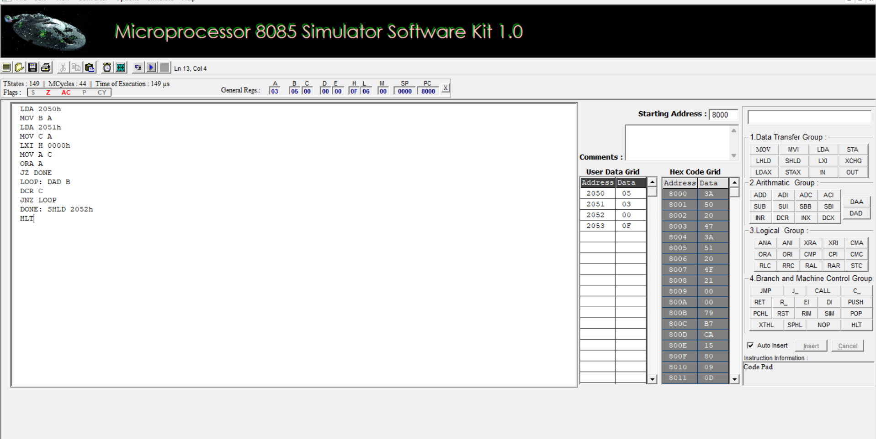
8 bit Division
Program:
LXI H 2050h
MOV B M
MVI C 00h
INX H
MOV A M
LOOP: CMP B
JC DONE
SUB B
INR C
JMP LOOP
STA 3050h
DONE: STA 3050
MOV A C
STA 3051h
HLT
OUTPUT:
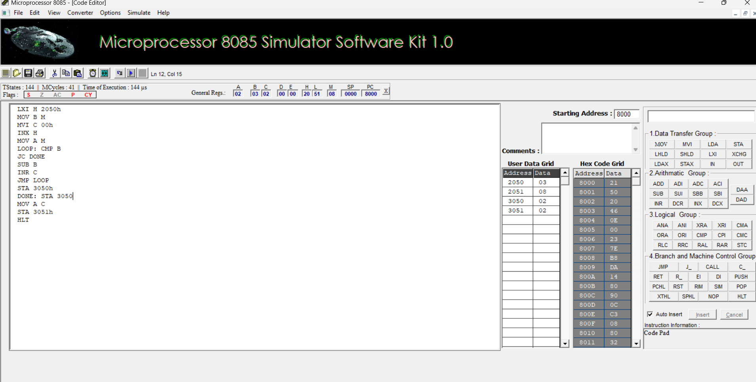

To Develop and Verify 16 bit Multiplication and Division
16 bit Multiplication
Program :
LHLD 2050h
XCHG
LHLD 2052h
SPHL
LXI H 0000h
LXI B 0000h
LOOP: DAD SP
JNC NEXT
INX B
NEXT: DCX D
MOV A E
ORA D
JNZ LOOP
SHLD 2054h
MOV L C
MOV H B
SHLD 2056h
HLT
OUTPUT:
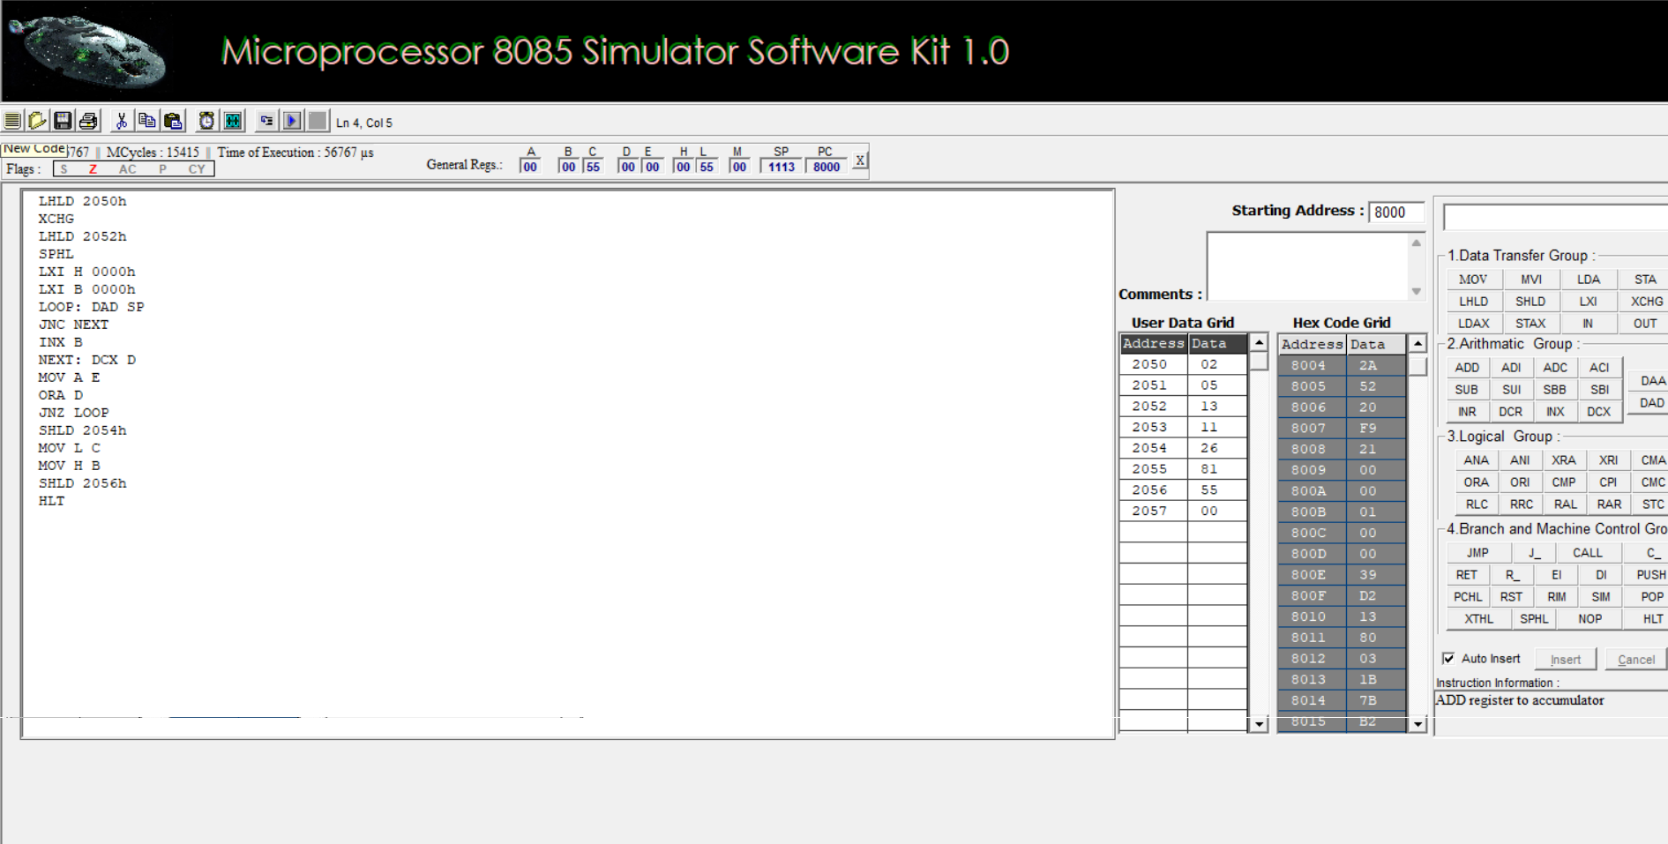

16 Division
Program
LXI B 0000h
LHLD 2052h
XCHG
LHLD 2050h
MOV A L
200B: SUB E
MOV L A
MOV A H
SBB D
MOV H A
JC 2017
INX B
JMP 200B
2017: DAD D
SHLD 2056h
MOV L C
MOV H B
SHLD 2054h
HLT
OUTPUT:
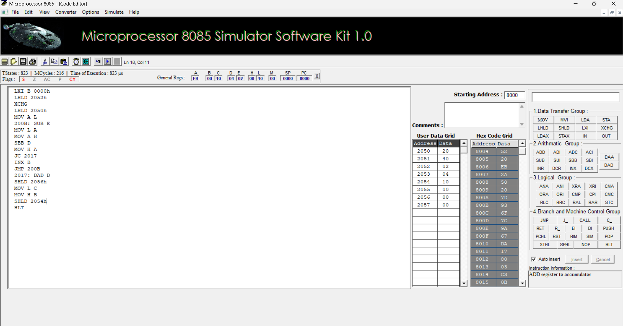

EXPERIMENT 2
I. 8-bit AND Operation
1. AIM
To write and execute an 8085 assembly language program to perform an 8-bit AND logical operation.
2. OBJECTIVE OF THE PROGRAM
- To perform an AND operation on two 8-bit binary numbers.
- To understand the working of the ANA instruction.
- To store and verify the result in the specified memory location.
3. REQUIRED EQUIPMENTS
- Computer system
- 8085 Microprocessor Simulator
- Intel 8085 Microprocessor
4. PROCEDURE
- Open the 8085 simulator.
- Enter the required assembly language program.
- Enter the first input data at memory location 2050H.
- Enter the second input data at memory location 2051H.
- Execute the program.
- Check the accumulator contents.
- Verify the result stored at memory location 2052H.

Output
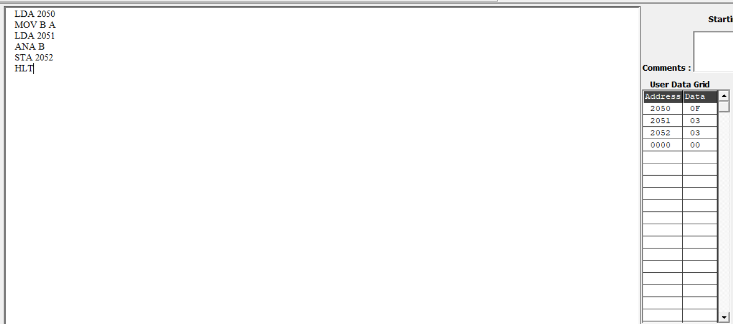

8-bit OR Operation
1. AIM
To write and execute an 8085 assembly language program to perform an 8-bit OR logical operation.
2. OBJECTIVE OF THE PROGRAM
- To perform an OR operation on two 8-bit binary numbers.
- To understand the working of the ORA instruction.
- To store and verify the result in the specified memory location.
3. REQUIRED EQUIPMENTS
- Computer system
- 8085 Microprocessor Simulator
- Intel 8085 Microprocessor
4. PROCEDURE
- Open the 8085 simulator.
- Enter the required assembly language program.
- Enter the first input data at memory location 2050H.
- Enter the second input data at memory location 2051H.
- Execute the program.
- Check the accumulator contents.
- Verify the result stored at memory location 2052H.

Output:-
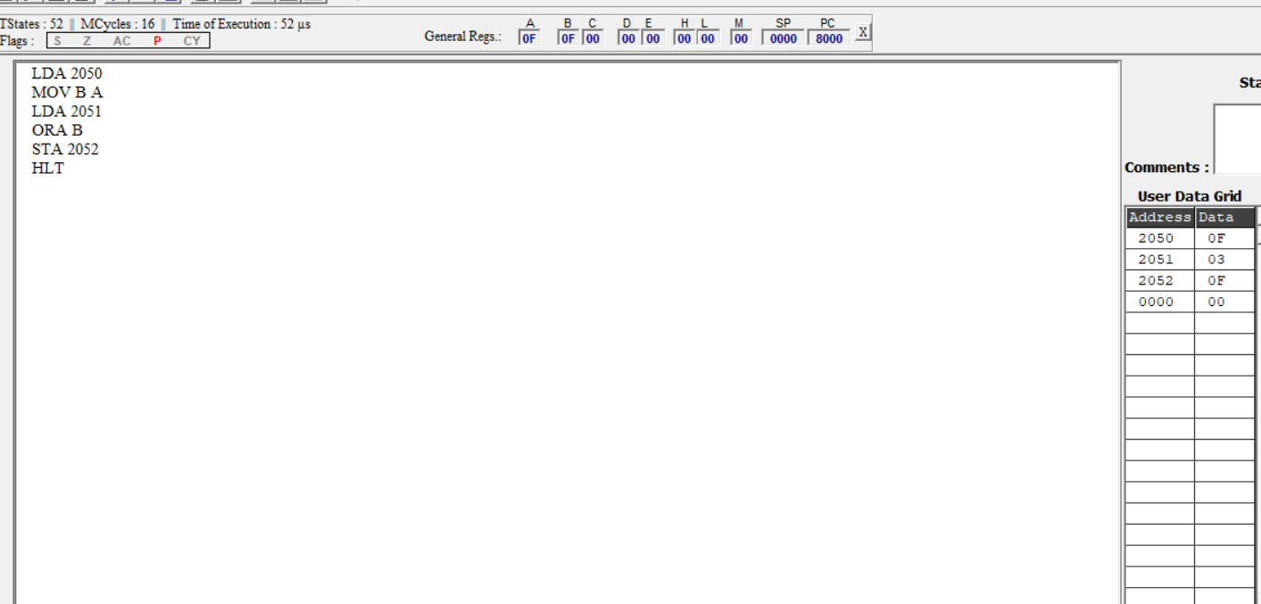

8-bit XOR Operation
1. AIM
To write and execute an 8085 assembly language program to perform an 8-bit XOR logical operation.
2. OBJECTIVE OF THE PROGRAM
- To perform an XOR operation on two 8-bit binary numbers.
- To understand the working of the XRA instruction.
- To store and verify the result in the specified memory location.
3. REQUIRED EQUIPMENTS
- Computer system
- 8085 Microprocessor Simulator
- Intel 8085 Microprocessor
4. PROCEDURE
- Open the 8085 simulator.
- Enter the required assembly language program.
- Enter the first input data at memory location 2050H.
- Enter the second input data at memory location 2051H.
- Execute the program.
- Check the accumulator contents.
- Verify the result stored at memory location 2052H.

Calculation:
0F = 00001111
03 = 00000011
--------
0C = 00001100

Output:-
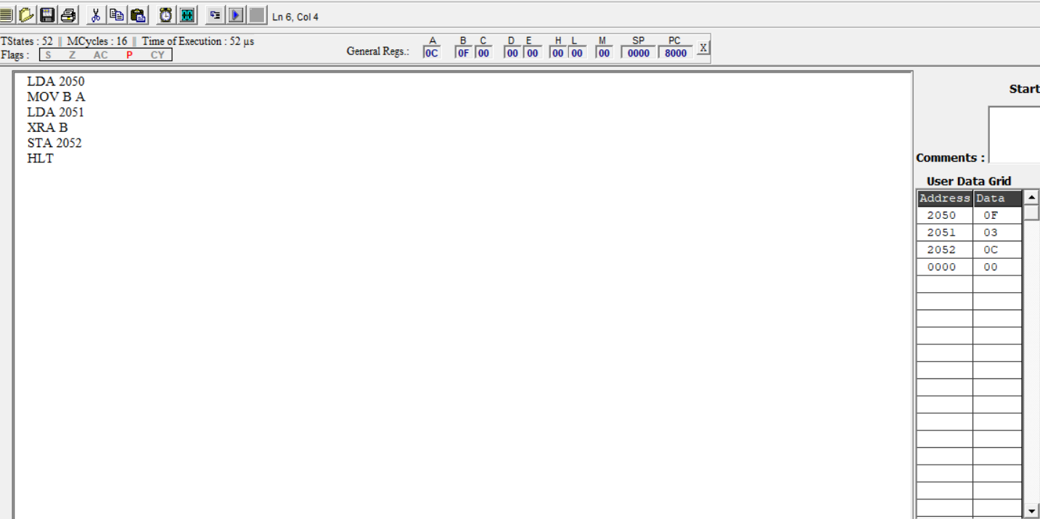

8-bit NOT Operation
1. AIM
To write and execute an 8085 assembly language program to perform an 8-bit NOT logical operation.
2. OBJECTIVE OF THE PROGRAM
- To perform a NOT operation on an 8-bit binary number.
- To understand the working of the CMA instruction.
- To complement all bits of the given 8-bit number.
- To store and verify the complemented result.
3. REQUIRED EQUIPMENTS
- Computer system
- 8085 Microprocessor Simulator
- Intel 8085 Microprocessor
4. PROCEDURE
- Open the 8085 simulator.
- Enter the required assembly language program.
- Enter the input data at memory location 2050H.
- Execute the program.
- Check the accumulator contents.
- Verify the result stored at memory location 2051H.

Calculation:
Input: 0F = 00001111
Output: F0 = 11110000

Output:-
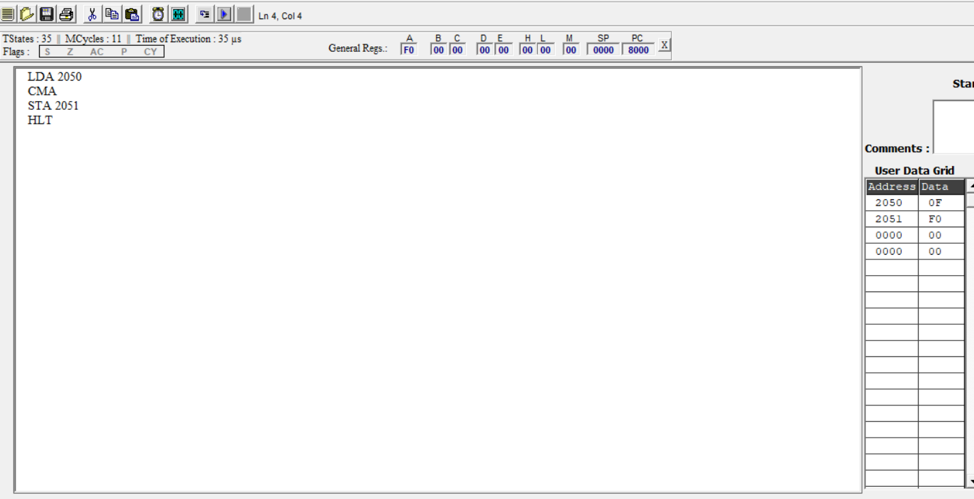

8-bit Bit Set Operation
1. AIM
To write and execute an 8085 assembly language program to set a particular bit of an 8-bit number.
2. OBJECTIVE OF THE PROGRAM
- To set a selected bit in an 8-bit binary number.
- To understand the working of the ORI instruction.
- To perform bit manipulation using logical OR.
- To store and verify the modified result.
3. REQUIRED EQUIPMENTS
- Computer system
- 8085 Microprocessor Simulator
- Intel 8085 Microprocessor
4. PROCEDURE
- Open the 8085 simulator.
- Enter the required assembly language program.
- Enter the input data at memory location 2050H.
- Execute the program.
- Check the accumulator contents.
- Verify the result stored at memory location 2051H.

Calculation:
Input: 08 = 00001000
Mask: 01 = 00000001
--------
Output: 09 = 00001001

Output:-
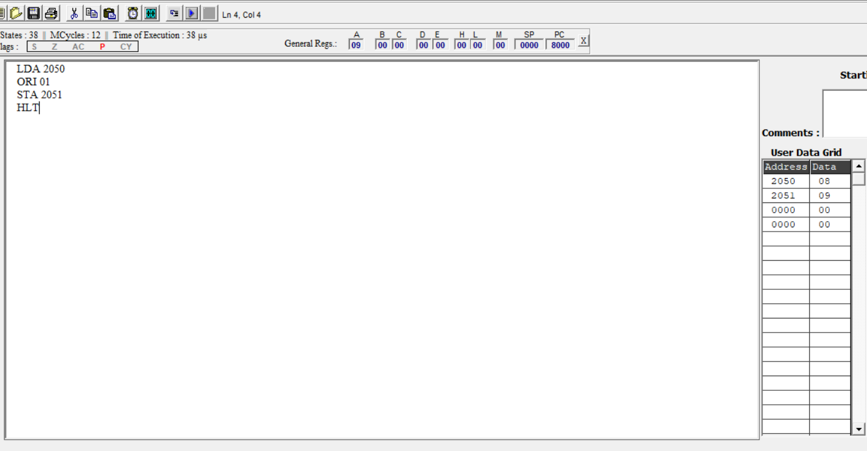

8-bit Bit Reset Operation
1. AIM
To write and execute an 8085 assembly language program to reset a particular bit of an 8-bit number.
2. OBJECTIVE OF THE PROGRAM
- To reset a selected bit in an 8-bit binary number.
- To understand the working of the ANI instruction.
- To perform bit manipulation using logical AND.
- To store and verify the modified result.
3. REQUIRED EQUIPMENTS
- Computer system
- 8085 Microprocessor Simulator
- Intel 8085 Microprocessor
4. PROCEDURE
- Open the 8085 simulator.
- Enter the required assembly language program.
- Enter the input data at memory location 2050H.
- Execute the program.
- Check the accumulator contents.
- Verify the result stored at memory location 2051H.

Calculation:
Input: 09 = 00001001
Mask: FE = 11111110
--------
Output: 08 = 00001000

Output:-
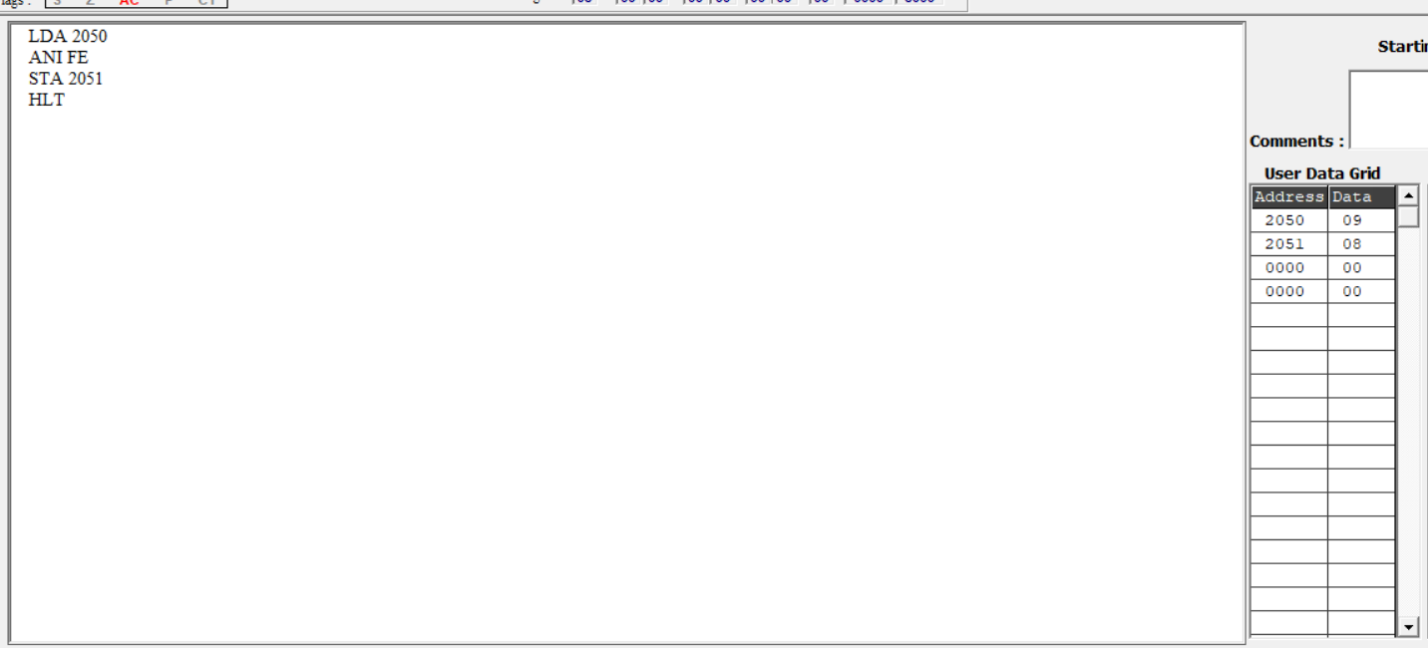

8-bit Left Shift Operation
1. AIM
To write and execute an 8085 assembly language program to perform an 8-bit left shift operation.
2. OBJECTIVE OF THE PROGRAM
- To shift the bits of an 8-bit binary number one position to the left.
- To understand the working of the ADD A instruction.
- To perform left shift using an arithmetic addition operation.
- To store and verify the shifted result.
3. REQUIRED EQUIPMENTS
- Computer system
- 8085 Microprocessor Simulator
- Intel 8085 Microprocessor
4. PROCEDURE
- Open the 8085 simulator.
- Enter the required assembly language program.
- Enter the input data at memory location 2050H.
- Execute the program.
- Check the accumulator contents.
- Verify the result stored at memory location 2051H.

Calculation:
Input: 05 = 00000101
Output: 0A = 00001010

Output:-
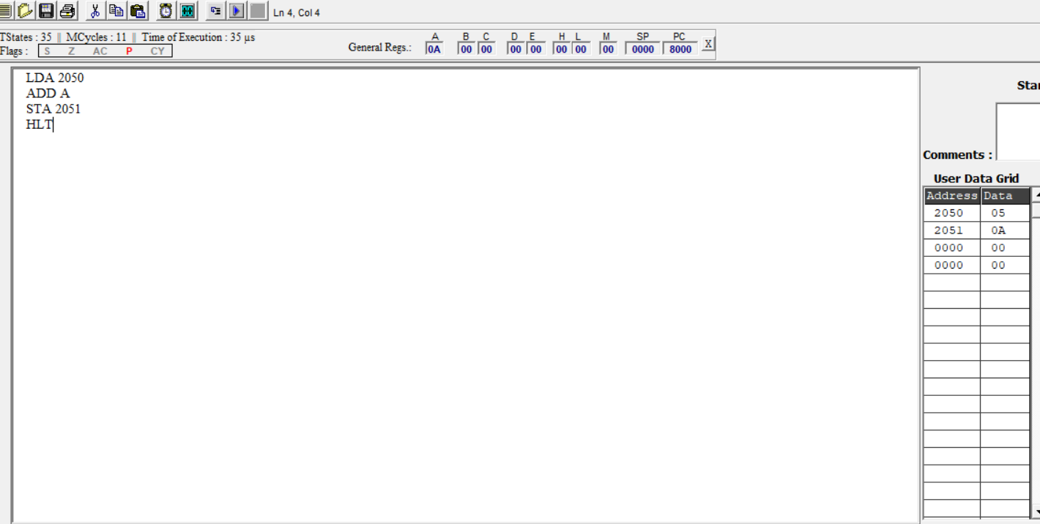

VIII. 8-bit Right Shift Operation
1. AIM
To write and execute an 8085 assembly language program to perform an 8-bit right shift operation.
2. OBJECTIVE OF THE PROGRAM
- To shift the bits of an 8-bit binary number one position to the right.
- To understand the working of the RAR instruction.
- To perform right shift using the rotate accumulator operation.
- To store and verify the shifted result.
3. REQUIRED EQUIPMENTS
- Computer system
- 8085 Microprocessor Simulator
- Intel 8085 Microprocessor
4. PROCEDURE
- Open the 8085 simulator.
- Enter the required assembly language program.
- Enter the input data at memory location 2050H.
- Execute the program.
- Check the accumulator contents.
- Verify the result stored at memory location 2051H.

Calculation:
Input: 0A = 00001010
Output: 05 = 00000101

Output:-


